**OOP WS31 ATTENDANCE TO CLASS**

**DATE: 02th february 2022**

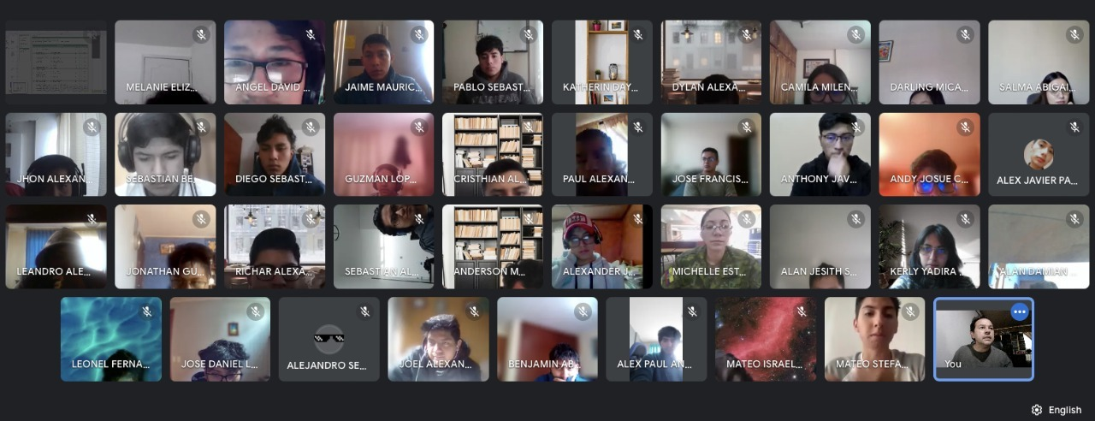

**Complete picture (Show all the face) → 10**

**Incomplete picture (Do not show all the face) → 9**

**Camera off → 7**

15 CRUZ PANTOJA DARLING MICAELA 9